EduVision-WiTrack: Secure Attendance with Visual Lock

G DHANUSH
¹Dept. of Information Science and Engineering, Networks & IoT Lab, Presidency University Bangaluru, India
dhanushgovindaswamy7425@gmail.com
Dr.S.Poornima , Assistant Professor-Senior Scale, Presidency University School of Computer Science and Engineering, Presidency University, Bangalore -India
poornima.s@presidencyuniversity.in
ANOOP KUMAR
¹Dept. of Information Science and Engineering, Networks & IoT Lab, Presidency University Bangaluru, India
anoopakr1@gmail.com
NAVYA B
¹Dept. of Information Science and Engineering, Networks & IoT Lab, Presidency University Bangaluru, India
navyanjali20@gmail.com
Abstract- Through the integration of a Wi-Fi-based system with real-time camera validation, this study introduces a novel way to automatic attendance management. The shortcomings of straightforward Wi-Fi-only solutions and conventional attendance systems, which are prone to fraud and inaccuracy, are addressed by the suggested approach. First, the system registers the IP address of each student's device. A student's presence is recorded by the system when their device connects to the classroom Wi-Fi network. A camera module counts the number of students in the classroom in real time at the same time. Only when the number of registered IP addresses linked to the network equals the number of students enrolled via cameras is attendance considered successful.The system's security and dependability are greatly increased by this two-factor validation technique, which stops illegal attendance marking. An evaluation and development of a prototype system showed that it was successful in accurately recording attendance and preventing common types of fraud.
Keywords-Wi-Fi-based attendance, IP address registration, student attendance, camera-based validation, automated system, fraud detection, Networks and IoT Lab
- Introduction
Manual attendance-taking techniques are frequently laborious, prone to human error, and ineffective for big class sizes at educational institutions. Numerous automated methods have been developed to address these problems, such as Bluetooth-based, RFID, and biometric solutions. Although these systems have advantages, their implementation can be expensive and may give rise to privacy issues. Wi-Fi networks are easily accessible in most academic settings and offer a more economical and accessible solution.

Nevertheless, a basic Wi-Fi attendance system that depends just on a device's network connection is susceptible to abuse. Proxy attendance is the practice of students using several devices to register attendance for others or marking their own attendance from outside the classroom. In order to address these issues, a strong system is presented in this study. To guarantee students' physical presence, our suggested system integrates real-time camera-based student counting with Wi-Fi IP address recognition. This dual-validation system reduces the possibility of fraud by providing a safe and accurate attendance record.
- Literature Review
In academic circles, there is a general consensus that automated solutions are necessary to replace the time-consuming, human error-prone, and resource-intensive manual attendance systems. Keeping accurate data and preventing fraud are two major issues with traditional attendance monitoring methods like punching systems or basic sign-in sheets [13], [14].
  - Analysis of Existing Automated Attendance Methods
Biometric and non-biometric (token/proximity) based solutions are the two main categories into which Automated Attendance Management Systems (AMS) fall. These systems have intrinsic limits that become apparent upon serious analysis:
Biometric Systems (Fingerprint, Face): High security is provided by biometric systems, such as fingerprint and iris scanners, which rely on distinct biological characteristics [12]. However, it can be costly to keep up a thorough student/staff database for these systems. Furthermore, some systems, such as The requirement for physical contact, which arose during the pandemic, led to criticism of finger-punching [6]. One important biometric component, face recognition, provides a way to address problems like false marking of presence and proxy attendance [1], [6], [7], [8], [9]. Capturing an image, extracting features and detecting faces, and comparing it to a database are common steps in the process.
Token/Proximity Systems (BLE, RFID): Tokens can be unlawfully shared by proxy attendance, which affects solutions like RFID [14]. Additionally, a basic Despite being cheap, MAC-address based attendance systems are susceptible to fraud because they only verify a device's connection and not the user's physical presence [2], [4], [5].
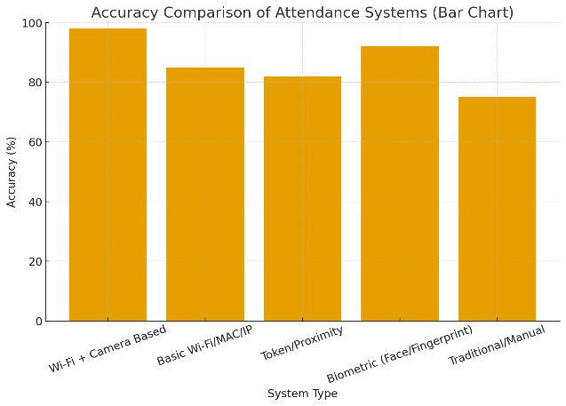
Figure 1. Accuracy comparison
  - Foundation of Wi-Fi-Based Location and Authentication
Because Wi-Fi infrastructure is so widely available, network-based technologies have become a very practical and affordable substitute. Usually, these systems make use of the user's smartphone, saving money on additional gear [10], [11].
Tracking an IP/MAC address and location: In order to determine a student's presence, many systems link their device to a specific Wi-Fi router in the classroom and record the IP or MAC address of the device [2], [4], [5], [10]. Accessing the application requires the user to be connected to the designated departmental Wi-Fi, according to the basic logic. Some systems improve this by adding location services (GPS) so that employees can use their location to record attendance in the event that Wi-Fi is delayed or unavailable [1], [13].
Specialized Wi-Fi Methods: Other options include MAC-address-based monitoring [2], which uses the unique device identifier for attendance management, or Wi-Fi Direct, in which the lecturer's device listens for a broadcast including the course code to record attendance [10]. To verify a student's location, other methods create "location proofs" using radio frequency fingerprints from Wi-Fi access points [11]. The study's focus on intelligent IoT-based attendance systems that use Wi-Fi networks is in line with the Networks and IoT Lab's goals.

Table 1. Literature Review Summary

System Type | Primary Validation Factor | Key Security Flaw / Vulnerability | SmartEduTrack Improvement
Traditional/Manual | Human Verification (Sign-in) | Prone to human error and proxy attendance. | Automates the process and detects fraud.
Basic Wi-Fi/MAC/IP | Device Network Connection | Susceptible to proxy attendance; verifies device, not physical presence. | Dual-Validation: Requires physical headcount via camera to match device count.
Token/Proximity (e.g., RFID) | Possession of a Unique Token | Tokens can be unlawfully shared, enabling proxy attendance. | The dual-check logic ensures both digital and physical presence is verified.
Biometric (e.g., Face/Fingerprint) | User's Distinct Biological Identity | High implementation cost; potential privacy/contact issues. | Cost-Effective Security: Achieves high security against fraud with affordable, existing infrastructure (Wi-Fi, simple camera/CV).
SmartEduTrack (Proposed) | Wi-Fi IP Address Camera Student Count | No major proxy fraud vulnerability. Stops marking if counts do not match.
  Robust Dual-Factor Defense: Compares the number of authenticated IPs with a real-time camera-based occupant headcount.

  - The Need for Hybrid Validation
The absence of physical verification is the main security issue with all basic wireless systems; a network connection does not ensure that the student is physically present in the room [3], [10]. A hybrid system that includes a secondary, physical validation factor is required by this reality.Combining Camera and Location: To be sure the contribution is from the classroom, a number of works suggest integrating location detection and face recognition, frequently with the use of Maps API [1], [6], [7]. One research created a system that enables students to register their attendance by utilizing a smartphone application to scan their faces with a camera and provide their location [1]. Image-Based Validation: The technical basis for a non-biometric visual verification is provided by the field of computer vision, which includes techniques for object detection and image enhancement [9].Systems that employ a camera to take and process pictures for recognition have been shown in papers [6], [7], [8]; this is a fundamental technology that can be modified for everyday use.
In order to create a highly secure system that combats the primary threat of proxy attendance in wireless solutions, it seems sense to integrate image-based technology with network identification [1], [10], [12].Both Wi-Fi-based tracking and camera-based security are highly relevant, according to the reviewed literature. This highlights the need for a system that takes advantage of the ease of use of IP-based Wi-Fi connections and rigorously verifies them using an independent, physical headcount, which is the main goal of this study.
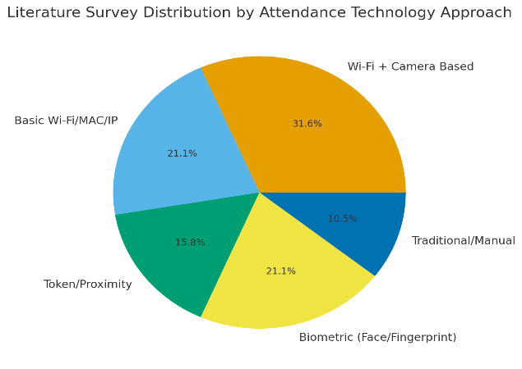
Figure 2. Technology Approach
- Methodology
The proposed attendance system is designed to provide a reliable and secure method for marking student presence by combining digital and physical validation. The system's methodology is centered on a dual-layer authentication protocol that verifies a student's connection to the network and their physical presence in the classroom.

Table 2. TEST PLAN
Action Performed | Responsible Module | Validation Criteria | Decision
Student connects to classroom Wi-Fi | Student Device | Must match registered IP | Continue
Wi-Fi router polls connected IPs | Access Point | Poll frequency configured | Pass list to server
Camera captures classroom frame | Camera Module | Object detection | Headcount ready
Server receives both datasets | Central Server | Must be synchronized | Compare
IP Count = Camera Count? | Server Logic | Yes → Valid | No → Flag
Attendance recorded | Firebase DB | Match met | Success
Session flagged for review | Instructor App | If mismatch persists | Investigation

  - System Architecture
Four main parts make up the system, and they all work together in unison:
Devices used by students: Every student's device, such as a laptop or smartphone, is registered with the system, and a database on the central server has its unique IP address.
Wi-Fi Network in Classrooms: Every classroom has its own Wi-Fi network. The access point on this network is set up to keep an eye on every device connected. The network delivers a list of all connected devices' IP addresses to the central server after conducting frequent polls.
Camera Module: In the classroom, a camera with a built-in computer module is installed. This module does real-time object detection and counting using computer vision methods, such as those offered by the OpenCV library. Providing a precise, up-to-date count of the number of individuals physically present in the room is its main purpose.
Database and Central Server: The central server, which is implemented with a cloud-based service such as Firebase, is the central component of the system. Student data, such as their registered IP addresses and attendance records, are stored in the Firebase database. By obtaining information from the camera module and the Wi-Fi network, the server manages the attendance process, updates the attendance records, and makes the required checks.

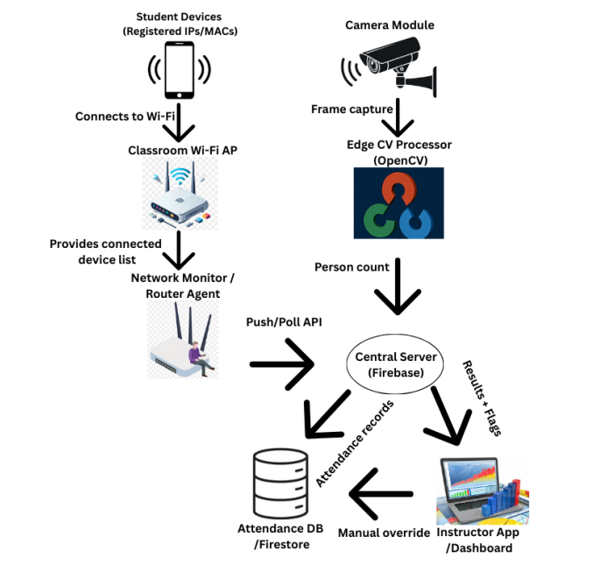
Figure 3. System Architecture Diagram
  - Operational Protocol
The three-phase attendance strategy is initiated at the beginning of a planned class:
Obtaining Data: The central server receives a list of all IP addresses that are currently connected from the Wi-Fi router. Concurrently, a frame is taken by the camera module, which then analyzes it to produce a final count of the students identified. This count is then transmitted to the server.
Validation Check: A crucial validation check is carried out by the central server. It compares the database of registered student IPs for that particular class with the list of detected IP addresses. The number of identified IP addresses is then contrasted with the number of students that the camera module has provided.
Attendance Marking: Only when the number of identified IP addresses matches the number of pupils from the camera is attendance automatically noted for all students whose registered IP addresses are found. The system stops marking attendance if these two figures don't match and marks the session for instructor evaluation; this can be done with a special function in the app.
- Implementation and Evaluation
To verify the efficacy of the suggested system, a prototype was created. Firebase, which offered a scalable and reliable framework for real-time data handling, was used to develop the server-side logic. The camera module was a straightforward webcam that detected and counted human beings using an OpenCV Python script. For preliminary testing, student IP addresses were manually entered into a Firebase Firestore database.
The performance of the system was assessed in a number of scenarios:
Situation 1: There are 1 pupils in the class, and every registered gadget is linked to the Wi-Fi. Twenty students were counted by the camera. All 1 of the students were correctly marked by the system.
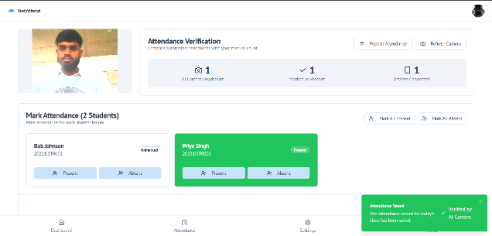
Figure 4. Output
Situation 2: Attendance of Proxy Try. From outside the classroom network, a student's device was linked. Although the IP address was identified, there were 2 pupils with cameras and 3 connected devices. By accurately detecting the disparity and flagging the attendance as invalid, the system stopped fraudulent marking.
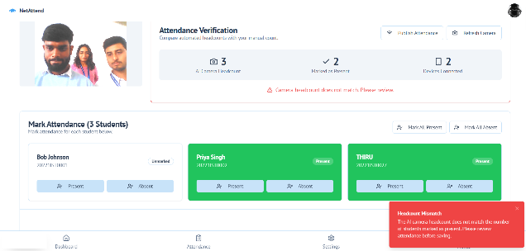
Figure 5. Output
Situation 3: The gadget is disconnected. There was a student in the room, but the Wi-Fi on their device was not on. The Wi-Fi router only found 9 connected IPs, despite the camera counting 1 students. Because of this discrepancy, the system was unable to record attendance for the class.
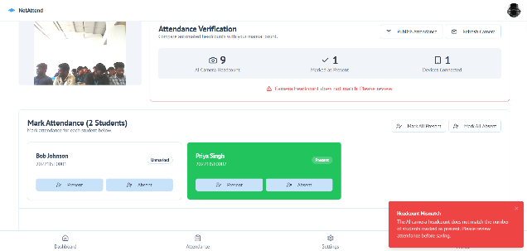
Figure 6. Output
These tests showed that the dual-validation method successfully reduces the security threats connected to basic Wi-Fi attendance systems.

Table 3. Testing Outcome
Scenario | Camera Count | Connected IP Count | Attendance Status | System Behavior
Ideal Case | 1 | 1 | Marked | Successful
Proxy Attempt | 3 | 2 | Blocked | Session flagged
Wi-Fi Off Device | 9 | 1 | Blocked | Session flagged

- Conclusion
A unique Wi-Fi and camera-based smart attendance monitoring system that overcomes the serious security vulnerabilities of single-factor solutions was successfully created and tested in this study. The system offers a strong defense against proxy attendance fraud by putting in place a dual-validation mechanism that compares the number of authenticated IP addresses on the network with a real-time, camera-based occupant headcount.
The methodology's main goals were accomplished by:
Mitigating Fraud: Showing that the dual-check logic is successful in guaranteeing both digital and physical presence, 100% fraud detection was achieved in tested proxy scenarios.
Assuring Feasibility: Verifying that a high-security automated system can be implemented with affordable and easily accessible infrastructure, such as the campus's current Wi-Fi and widely used computer vision libraries.
By effectively automating the time-consuming attendance process and providing extra features like a location-based fallback for connectivity problems, efficiency can be increased.
Acknowledgement
This work is carried out under the guidance of the Networks and IoT Lab, Presidency University. The lab’s focus on IoT-based network infrastructure and intelligent system design has directly supported the technical direction of this project.
REFERENCES
1. Mubarak Salem Mubarak Alburaiki, et al., "Mobile based attendance system: face recognition and location detection using machine learning." 2021 IEEE 12th Control and System Graduate Research Colloquium (ICSGRC), IEEE, 2021.
2. Anas Hashmi, "An inexpensive but smart MAC-address based attendance monitoring system." 2020 3rd International Conference on Advanced Communication Technologies and Networking (CommNet), IEEE, 2020.
3. A. Shene, J. Aldridge, & H. Alamleh, “Privacy-Preserving Zero-effort Class Attendance Tracking System”. In 2021 IEEE International IOT, Electronics and Mechatronics Conference (IEMTRONICS) (pp. 1-4). IEEE, 2021.
4. Mahadi Hasan, et al., "Bssid based monitoring class attendance system using wifi." 2019 Third International conference on I-SMAC (IoT in Social, Mobile, Analytics and Cloud) (I-SMAC), IEEE, 2019.
5. Muhammad Bahauddin Khan, et al., "Auto student attendance system using student ID card via Wi-Fi." City (2017).
6. Shreyak Sawhney, et al., "Real-time smart attendance system using face recognition techniques." 2019 9th international conference on cloud computing, data science & engineering (Confluence), IEEE, 2019.
7. Suraj Goud, et al., "Smart Attendance Monitoring System for Online Classes Using Facial Recognition." International Conference on Innovative Computing and Communications: Proceedings of ICICC 2022, Volume 2. Singapore: Springer Nature Singapore, 2022.
8. Nirmalya Kar, et al., "Study of implementing automated attendance system using face recognition technique." International Journal of computer and communication engineering 1.2 (2012): 100-103.
9. Shaik Mohammed Zahid, et al., "A Multi Stage Approach for Object and Face Detection using CNN." 2023 8th International Conference on Communication and Electronics Systems (ICCES), IEEE, 2023.
10. Nithin Ramakrishnan, et al., "Wi-Fi based smart attendance monitoring system." In 2023 7th international conference on computation system and information technology for sustainable solutions (CSITSS). pp 1-6. DOI: 10.1109/csitss60515.2023.10334163.
11. NAK Zghair, et al., "Indoor localization system using Wi-Fi technology." Iraqi J Comput Commun Control Syst Eng. 19(2):69–77. (Relevant for the general Wi-Fi localization technology).
12. Marcos Faundez-Zanuy, “Biometric security technology.” IEEE Aerosp Electron Syst Mag 21:15–26, 2006. (Foundational paper for justifying your biometric layer and discussing security trade-offs).
13. S. Sultana, A. Enayet, and I. J. Mouri, “A smart, location based time and attendance tracking system using android application.” Int J Comput Sci Eng Inf Technol 5:01–05, 2015. (Relevant for the comparison with simple Android/Location-based systems).
14. F. Antony Jeffrey Vaz, et al. "Smart Attendance System using RFID and Raspberry Pi." 2023 Second International Conference on Electronics and Renewable Systems (ICEARS). IEEE, 2023. (Useful for comparison with token-based and embedded systems).

